Booster Draft Primer
Randy Buehler
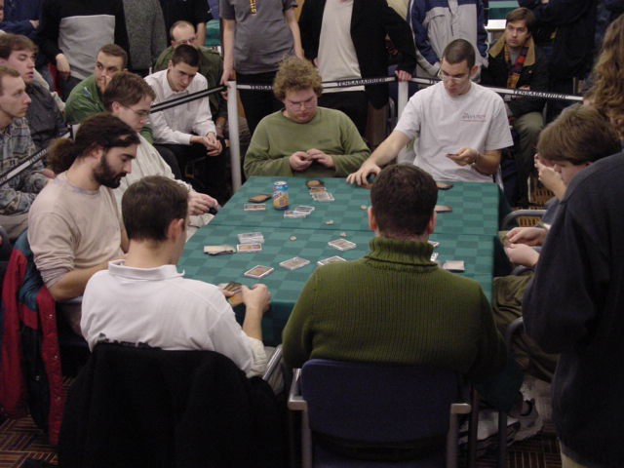
I was talking to the Ferret (or is it The Ferret) at Pro Tour Los Angeles and he lamented the lack of basic draft strategy articles available on the Internet. On the one hand, I disagree with all the recent complaining about the sorry state of Internet writing. In fact, I was struck last week by how good the articles were that I read. Friggin' Rizzo's "Bringing Out the Dead" was, quite simply, a fine piece of literature. While it wasn't pro-level strategy, it did a great job of demonstrating the tremendous depth that Magic articles are capable of. There's a whole lot more to the genre than just strategy articles and authors who recognize this and write to their strengths make the community a better (and more entertaining) place. Meanwhile Brian Kibler wrote a fine PT LA report that I thought captured not just his strategy for the Pro Tour, but also the flavor of the whole Boat experience. And Zvi rebounded nicely from "My Fires" with perhaps the best Rochester Draft analysis I've ever read. On the other hand, I do think Ferret is right about the dearth of "How to Draft Like a Pro" articles, so here goes:
If you want to learn how to booster draft like a pro, you have to learn a lot of things. You have to learn which cards are better than which. You also have to learn to analyze a set to determine which colors are better (the trick here is to completely ignore the rares, merely glance at the uncommons, and spend most of your time just staring at and ranking the commons). You have to learn to modify your values for cards based on what you've already drafted. And, of course, you have to learn to play well after you draft your deck. However, this article isn't about any of those things. I want to look at the strategy of the draft itself - the part that doesn't really change much from set to set or even environment to environment.
You get a tremendous amount of information from the first few packs of any booster draft and I find it really helps to have a way to organize that information. The two fundamental concepts I used to take my booster draft game to the next level are, for lack of better terms, the "dominant" and "submissive" strategies.

"Dominate the guy on your left"
You don't have any control over the first pick of the person you feed for the first (and third) pack, but after that you get to influence each of his or her next fourteen picks. You can manipulate him or her by trying to strip all the good cards of one color out of each pack before passing it along. Without even realizing what you're up to, they will just naturally select cards of other colors. You can also choose to pass them a really good card of a color you're not playing so they'll wind up in that color instead of your color.
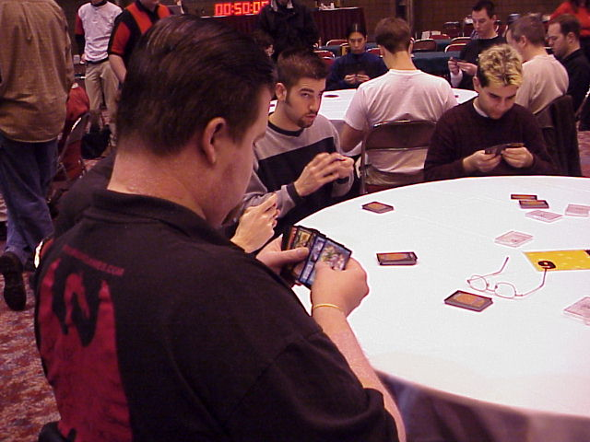
In both situations, the whole point behind your machinations is to set yourself up for the second set of packs. That's when the person on your left is going to be passing to you, and if you've done your job and dominated them properly, they'll hook you up. They don't even need to understand what's going on, they'll just naturally select cards of their colors and pass you the cards you want. This effect is so powerful that it's worth taking inferior cards during the first pack in order to set yourself up for the second. Your deck may not look great when you review your first 15 picks, but that's because you can't evaluate their full value without considering the position you've put yourself in.
When it works out, dominating the guy on your left is a very effective strategy. The packs won't always cooperate with you, though. If you open up two great cards of the same color, you're going to wind up passing at least one of them. (Some pros will draft an inferior card when put in this situation and pass both bombs rather than send a confusing signal.) You can't count on the dominant strategy if the packs come up this way, and so you shouldn't sacrifice any card quality in those situations.
The other situation where the dominant strategy doesn't work is when the color you're cutting off isn't all that good in the second set of packs. For example, if you're drafting Masques/Nemesis/Prophecy, you have to think about which colors are actually good in Nemesis. Green just wasn't good. It did have Blastoderm, but that was basically it. Red wasn't all that hot either. So dominating the guy on your left by cutting off red or green just wasn't a good strategy. You can probably succeed in getting that person out of red or black, but you won't get paid off for any of your first pack sacrifices because there just aren't enough good commons for him or her to pass you.
On the other hand, dominating black was a great strategy back in Masques/Nemesis/Prophecy booster draft. Black was solid in Masques and spectacular in Nemesis so you could make solid picks throughout Masques and then the black would just keep flowing during Nemesis. I believe Booster drafts are won and lost by what gets passed to you around 4th, 5th, and 6th pick. If you can set up a situation where multiple people in a row just keep passing your cards down the line to you, that's when you get 1st pick caliber cards 5th and that's win you win drafts. Dominating black in a full Masques block draft was the archetypical example of this. The same was true of blue in Saga/Legacy/Destiny drafts - if you could set yourself up to get passed Legacy blue cards, you were well on your way to winning. (Meanwhile Legacy white was awful and not worth changing your picks over.)

Submit to the guy on your right
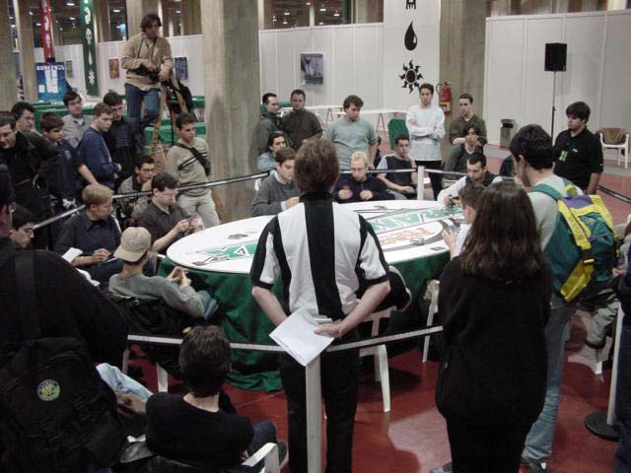
Just as you're sending lots of information to the guy on your left, so too are you receiving lots of information from the guy on your right. He's already taken a card from each of the packs he passes to you and he declined to draft each of the cards that's left. It usually takes me a few packs to figure out what color is consistently missing and which colors have good cards that are floating farther than they should. If you're lucky, you'll get a clear signal right away so you can switch into a color that's underdrafted on your right. (This is especially true if the guy on your right is running the dominant strategy on you.) However, the more typical situation is that you figure out what's really up around picks 4, 5, and 6. By then you can usually identify which color still has good cards in the packs. It may seem like it's too late to take advantage of this knowledge. Many players despair because they'll probably only get 1-2 more cards if they switch colors now. The trick is that you aren't supposed to switch because of what you'll get from the remnants of pack 1. You're supposed to switch because you'll get hooked up in the third set of packs!
If you're being passed good cards of a certain color halfway through pack 1, then you can expect to be passed good cards of that color starting at the very beginning of pack 3. If you switch now, your deck may not look spectacular as you review your first fifteen draft picks, but once again the full value of those picks has to include the position you've put yourself in. Ideally, the players on your right are just going to send your cards down the line in the third pack while they take the best available cards of their colors - a very good situation for you if you can set it up.
When faced with the decision of whether to submit to the guy on your right, you have to ask yourself how good the color you're switching into is in the third pack. Switching colors often requires you to give up on some of your early picks, so you only want to do it if you know your going to get paid off later on. The red in Prophecy is really good, so if you get some nice looks at late red cards in Masques, it might be worth switching in. However, if you get late looks at white, don't switch. The white in Prophecy just isn't good enough to justify a color change. (Troubled Healer might be the best common in the set, but that's all there is.)

Have an overall plan
So which strategy is better? Dominate or submit? I think the answer depends on the packs. I always hope to open a pack where the best card was in a color that had no other good cards. Then I could try to cut that color off without sacrificing much card quality. However, if the packs didn't cooperate or if the color of my first pick wasn't worth cutting off, then I would start paying careful attention to the packs I was picking up to try to find out what color was underdrafted on my right. Ideally, my first 4-5 picks would all be of one color so I could cut it off and by the time that color dried up I would have identified which color would make a good second color.

I'm sure some other pros would disagree with me. Pro Tour New York '99 Champion Casey McCarrel (who also finished 2nd at the Booster Draft Pro Tour Chicago '98), uses an exclusively submissive strategy. He simply takes the best card out of each pack and doesn't commit to any colors until very deep into the first pack. After he grinded his way into US Nationals last summer, I watched him draft five different colored cards with his first five draft picks (and this was Masques/Nemesis/Prophecy draft, not Invasion!)
I don't think either plan is strictly better. The truly well-rounded booster drafter will improvise and use all the available information form both the packs he's passing and the packs he's being passed to figure out what the proper approach is to any given draft. And that proper approach will change depending on the packs and the behavior of the people around him. The multi-colored nature of Invasion and Planeshift makes the situation even more complicated. Three-color decks are perfectly reasonable to draft and you also have to be prepared for your neighbors to draft them. However, I think the analytical tools I've sketched out here are still very useful. Often it helps to think of the five available colors as white/blue, blue/black, black/red, red/green, and green/white. And your mission is still the same: set up a situation where you are getting hooked up with really good cards late in packs. If you're in an Invasion/Planeshift draft you can accomplish this either by cutting off the flow of a color that you want to get back in the second pack or by recognizing that a good Planeshift color is underdrafted on your right.

